How To Create a S3 Bucket

**Step1🡪 Click on "Create bucket"**: In the S3 dashboard, click on the "Create bucket" button.

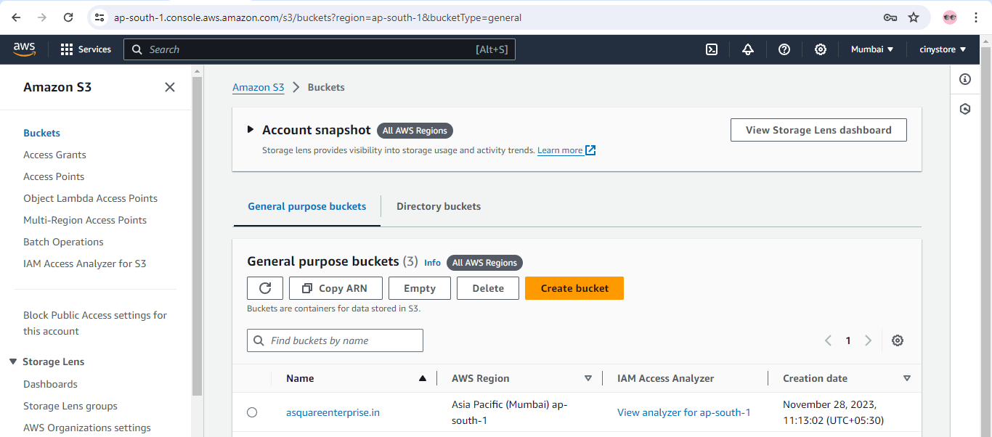

**Step2🡪 Enter Bucket Name**: Choose a unique name for your bucket. Bucket names must be globally unique across all of AWS, so you might need to try a few different names before finding one that's available.

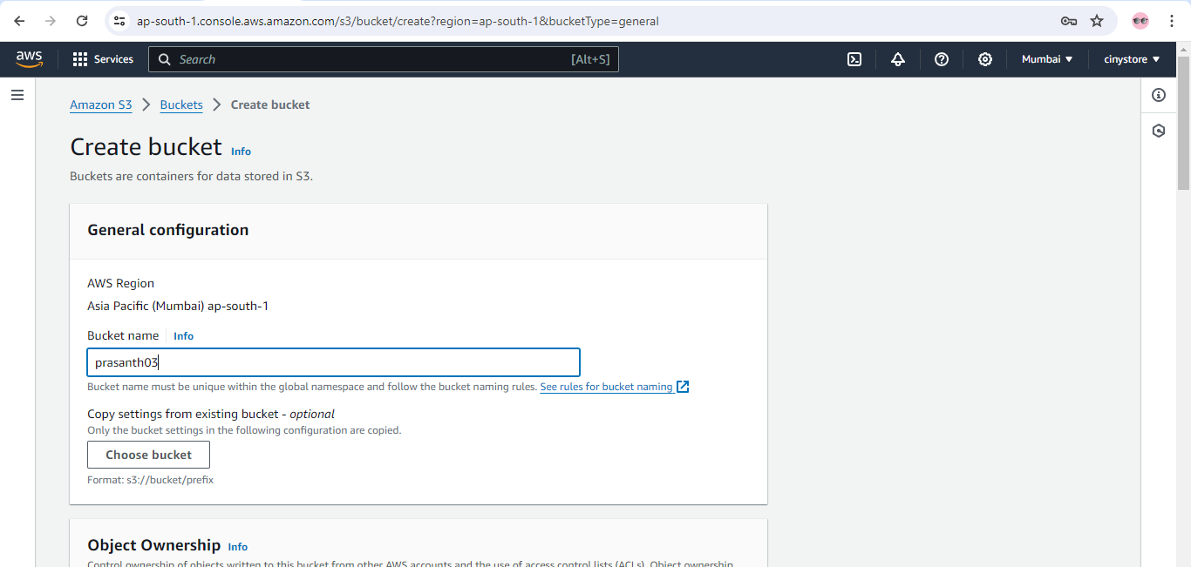

**Step3🡪 Object Ownership**

1. ACLs disabled (recommended)
2. Block Public Access settings for this bucket
3. Bucket Versioning – disable
4. Bucket Key – enable

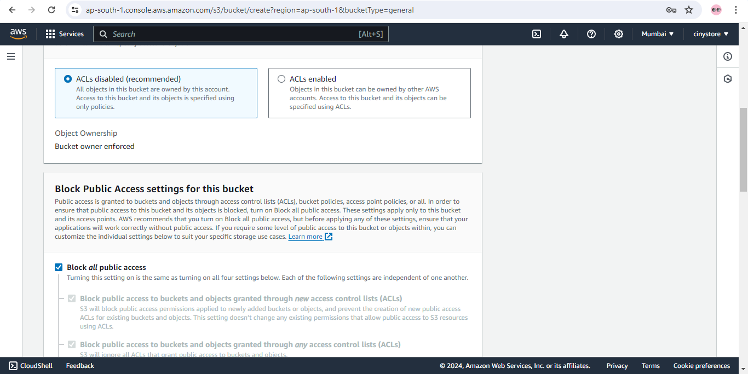

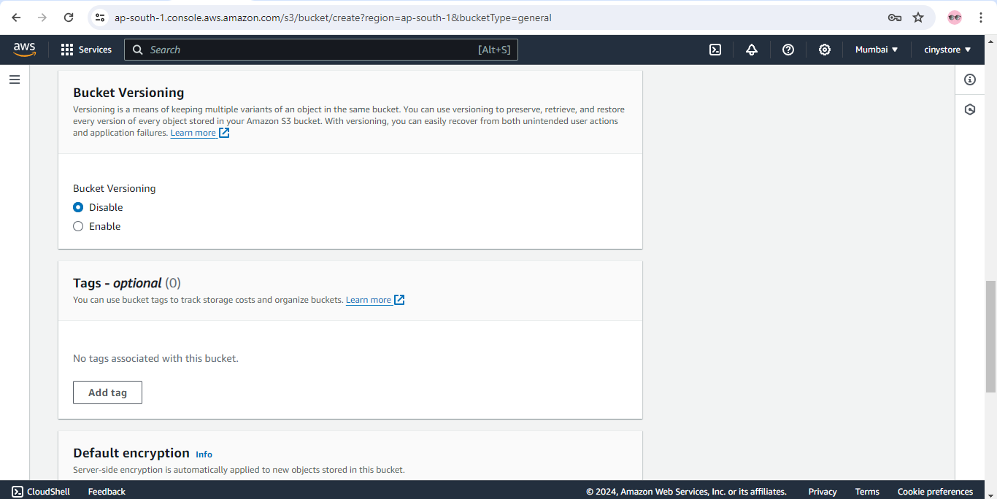

Default encryption -- Server-side encryption with Amazon S3 managed keys (SSE-S3)

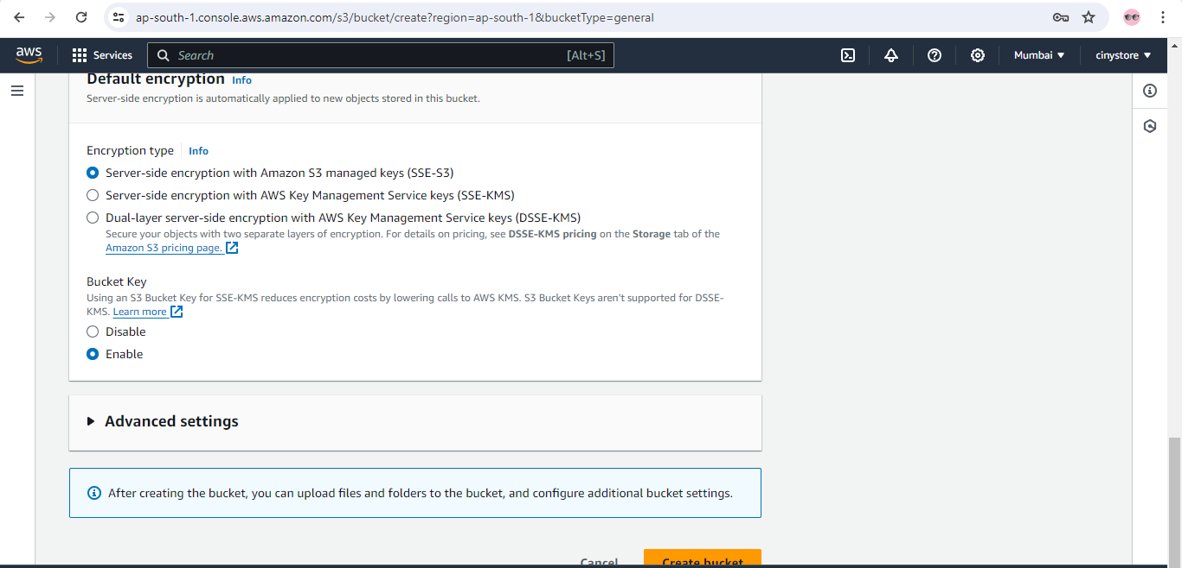

**Step4**🡪 Review all the settings you've chosen for your bucket. Make sure everything looks correct before proceeding.

**Step5**🡪 After verifying everything is ok then click on Create bucket.

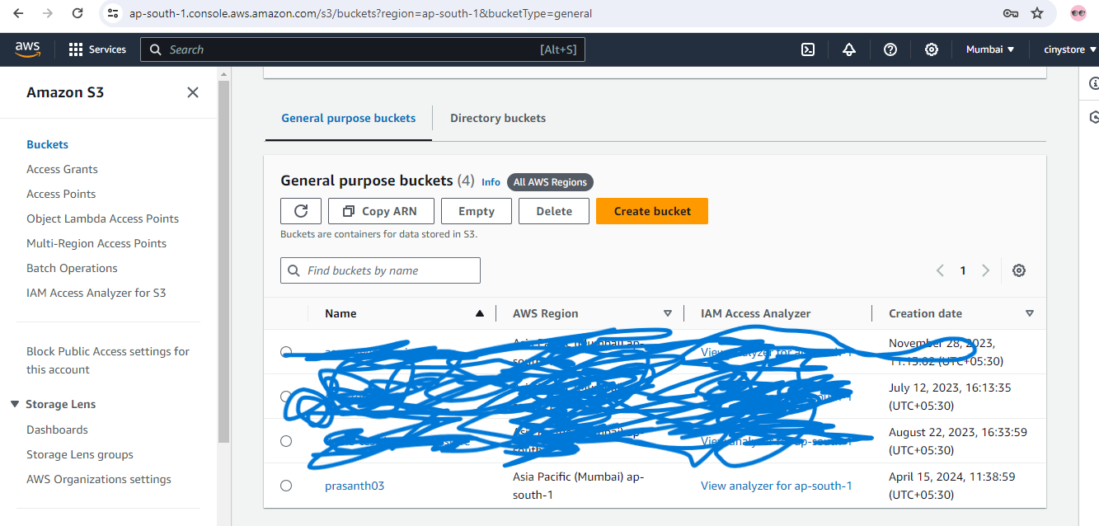

Bucket was successfully created as per given bucket name.

Click On Bucket name (prasanth03)

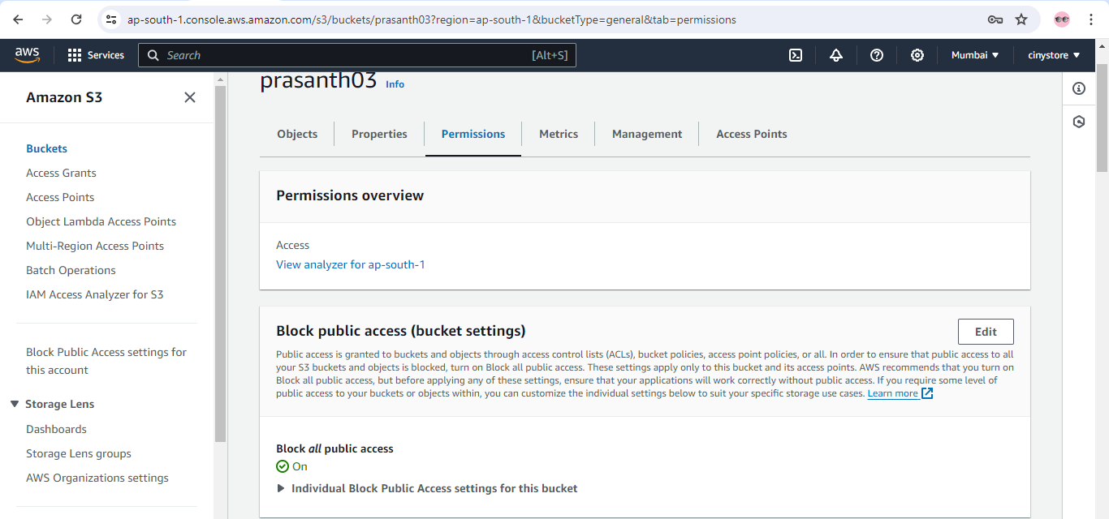

Click on edit and untick the **Block all public access then click on save changes.**

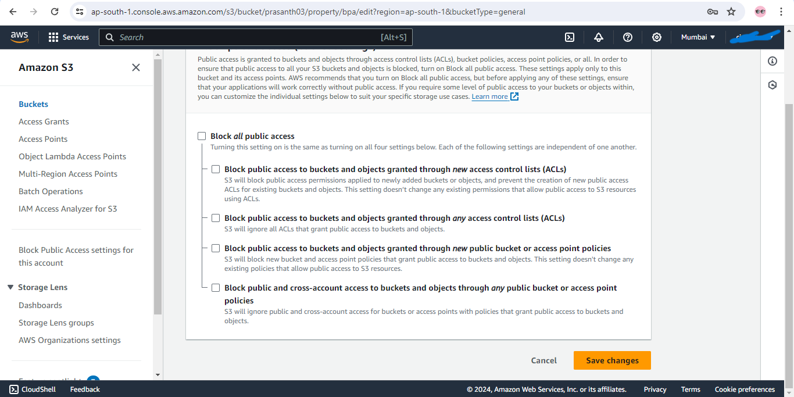

After clicking on save changes pop will come and confirm it.

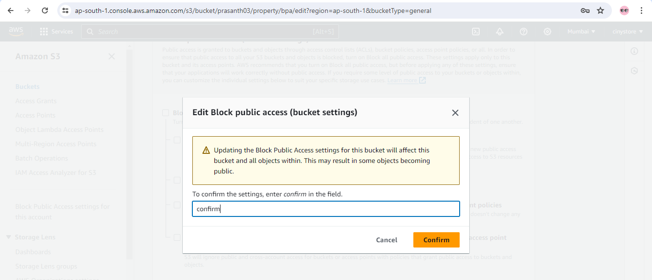

Step6🡪 **Bucket policy – Go to edit button click on it add these permission given below**

{

"Version": "2012-10-17",

"Statement": [

{

"Sid": "PublicReadGetObject",

"Effect": "Allow",

"Principal": "*",

"Action": "s3:GetObject",

"Resource": "arn:aws:s3:::prasanth03/*"

}

]

}

Add these in the policy as per bucket name.

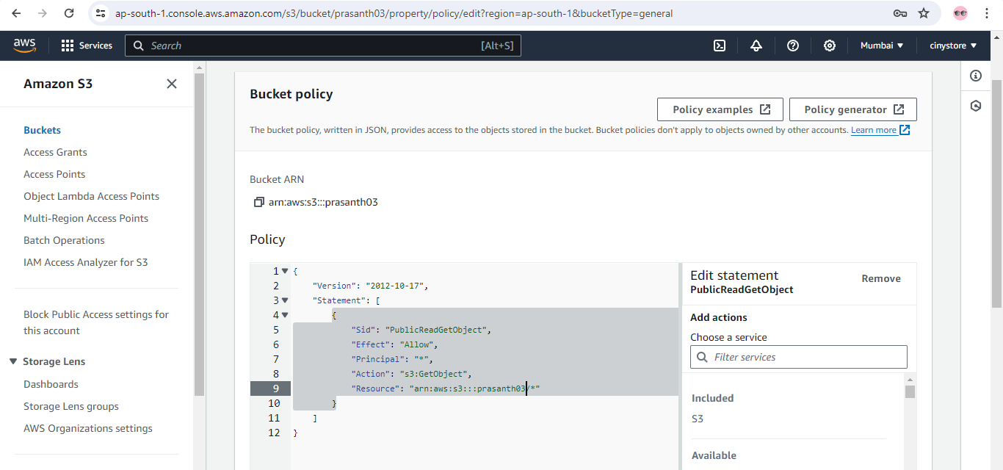

After adding policy in bucket policy section it will be publicly accessible as given in below screenshot.

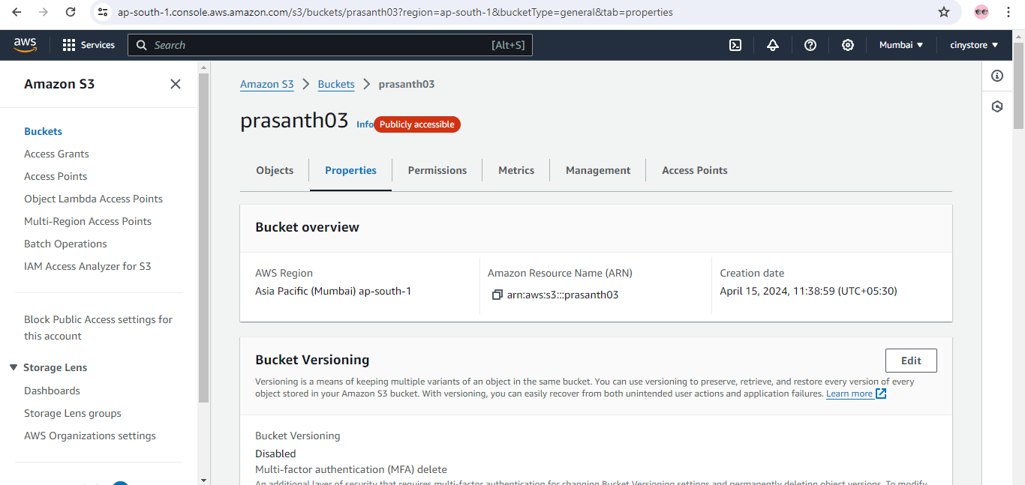

-🡪 For Example I had to host a static website follow these steps from below onwards

a) Upload some files for example here I am adding index.html and style.css

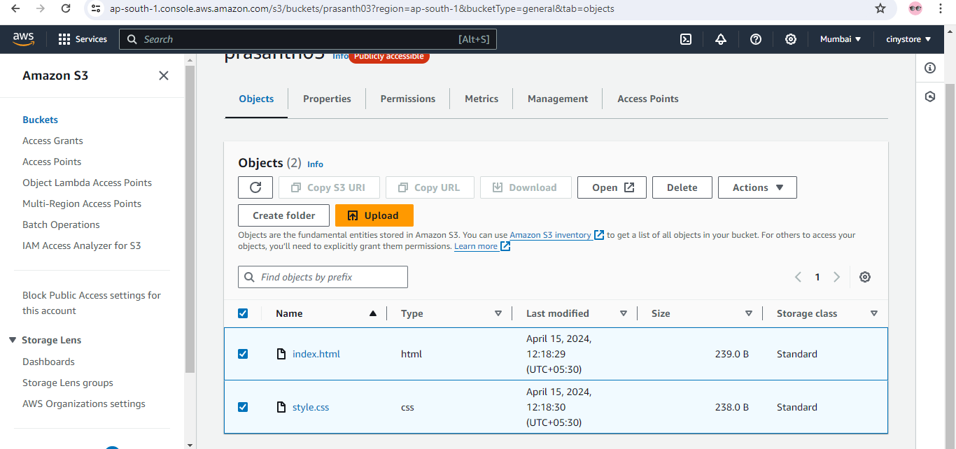

Go to the actions and click on move you will see a dashboard select destination type as General purpose bucket and browse S3 then select your bucket name and click on choose destination.

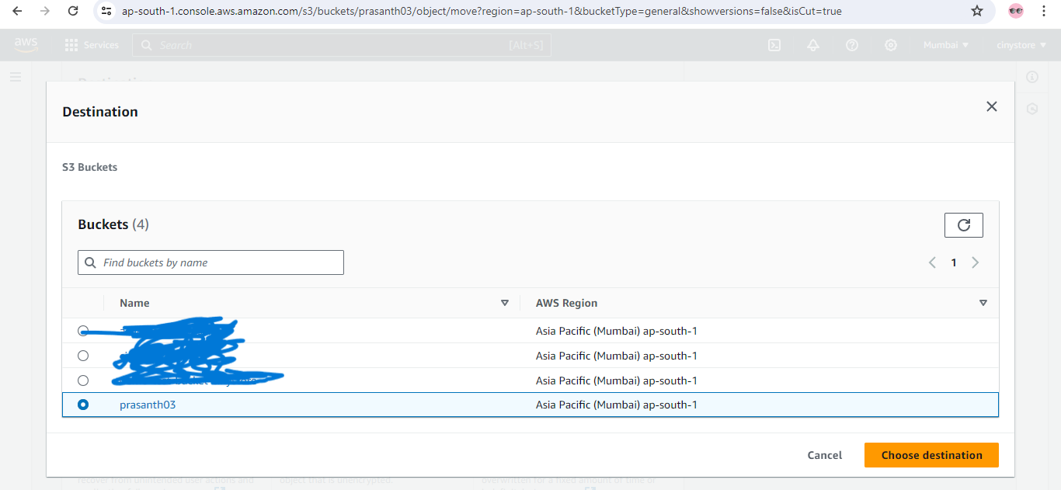

Go to Properties tab and go on to **Static website hosting** then click on edit

Static website hosting – enable

Hosting type -- Host a static website

Index document – index.html

Error document – error.html

After doing these click on save canges.

At last for reviewing purpose either website was hosted or not go to static web hosting

Click on link <http://prasanth03.s3-website.ap-south-1.amazonaws.com>

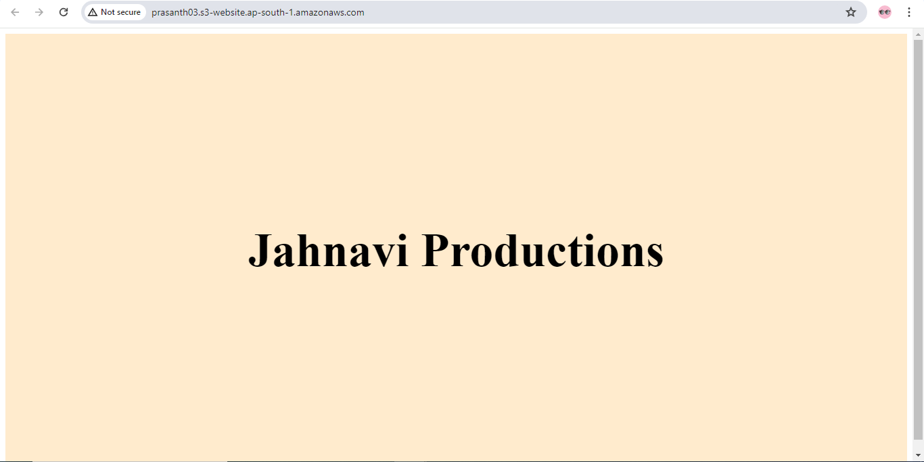

Note: These for communicate between S3 And Ec2 Instance same procedure as above but small change 🡪 In the Properties Sections go on to **Static website hosting** and click on edit

Static website hosting – enable

Hosting type -- Redirect requests for an object

Host name – 13.233.38.38 (public IP address of EC2 Instance)

Protocol – as per website (http, https)

\***This is all about S3 BUCKET** *